1. Two Sum Given an array of integers nums and an integer target, return indices of the two numbers such that they add up to target.

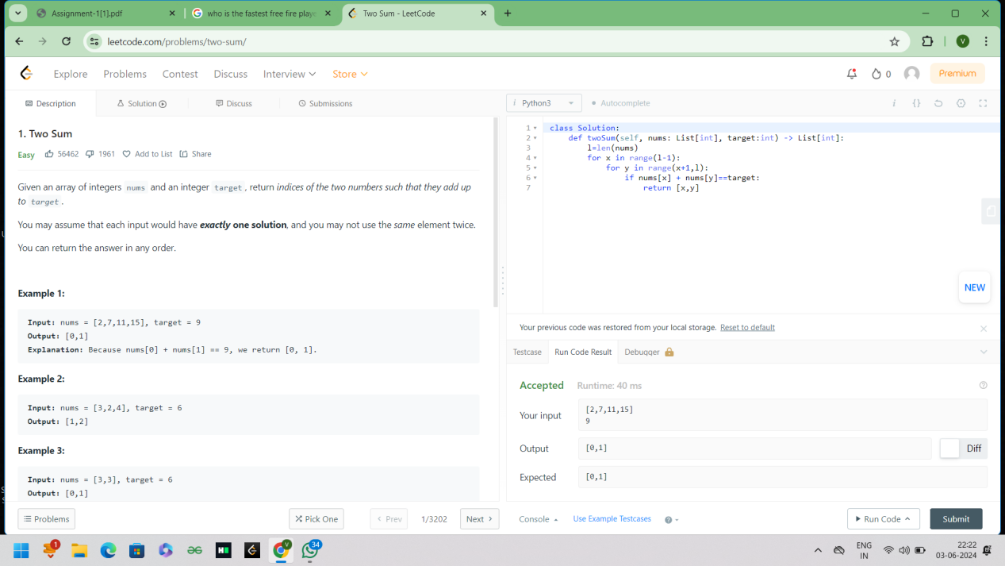

1. Add Two Numbers You are given two non-empty linked lists representing two non-negative integers. The digits are stored in reverse order, and each of their nodes contains a single digit. Add the two numbers and return the sum as a linked list. You may assume the two numbers do not contain any leading zero, except the number 0 itself

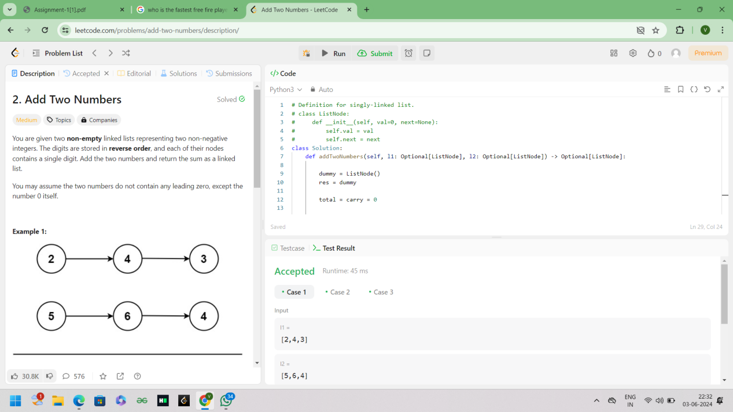

1. Longest Substring without Repeating Characters Given a string s, find the length of the longest substring without repeating characters.

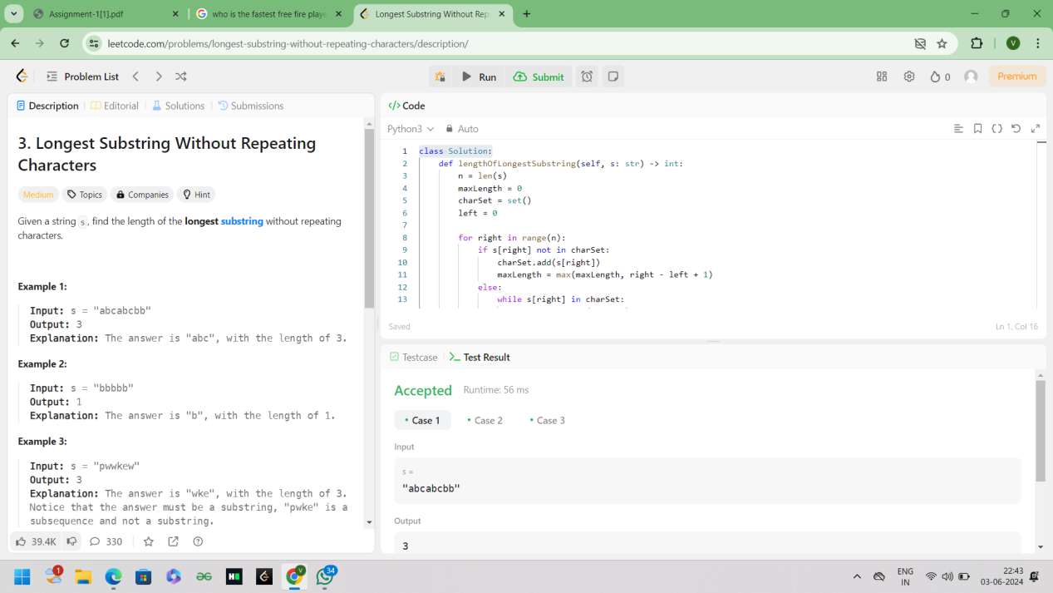

1. Longest Palindromic Substring Given a string s, return the longest palindromic substring in s.

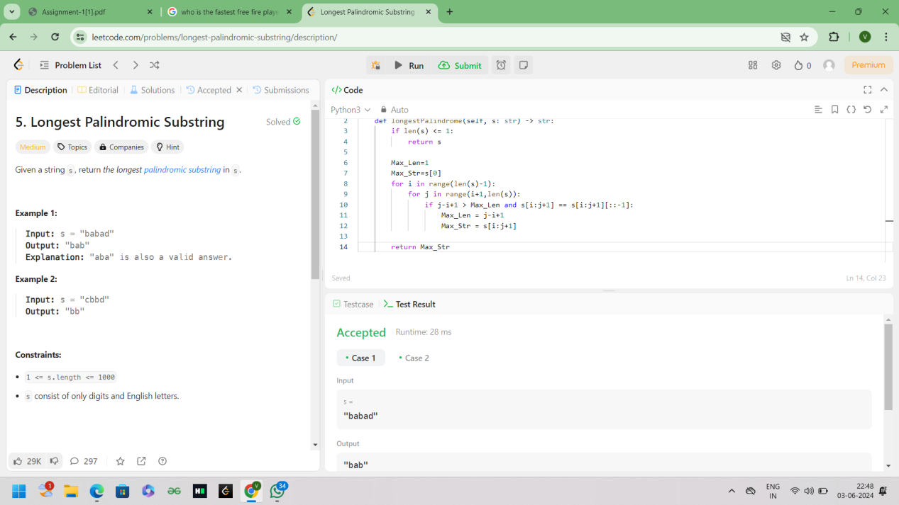

1. Zigzag Conversion The string "PAYPALISHIRING" is written in a zigzag pattern on a given number of rows like this: (you may want to display this pattern in a fixed font for better legibility) P A H N A P L S I I G Y I R And then read line by line: "PAHNAPLSIIGYIR" Write the code that will take a string and make this conversion given a number of rows: string convert(string s, int numRows);

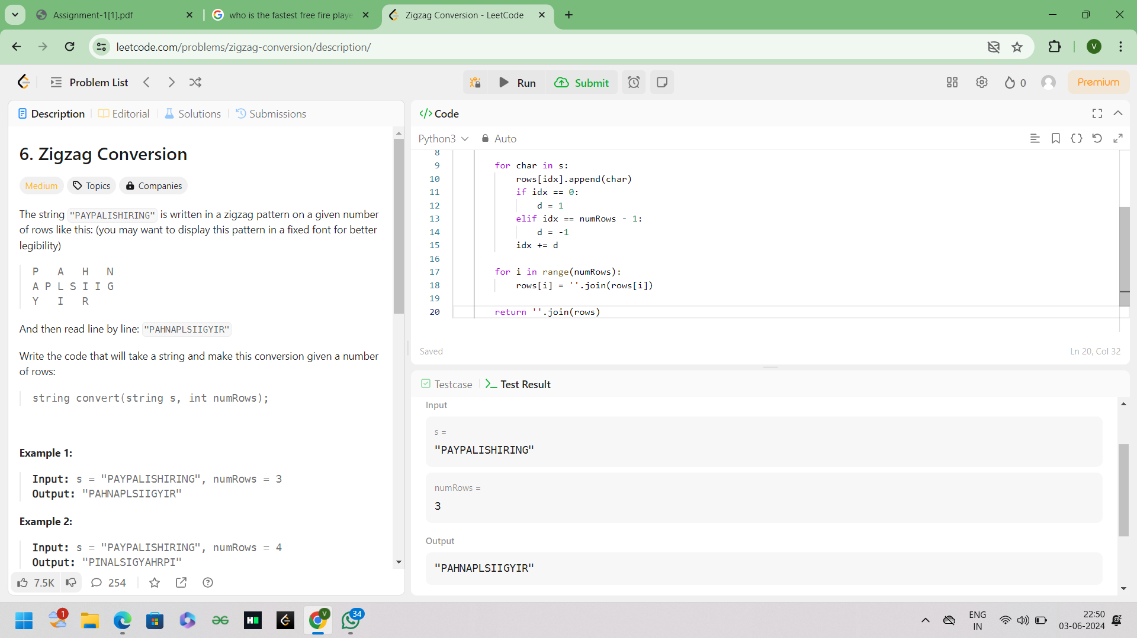

1. Reverse Integer Given a signed 32-bit integer x, return x with its digits reversed. If reversing x causes the value to go outside the signed 32-bit integer range [-231, 231 - 1], then return 0. Assume the environment does not allow you to store 64-bit integers (signed orunsigned).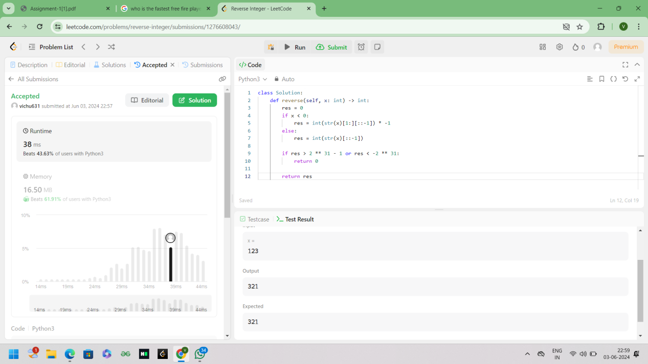
2. String to Integer (atoi) Implement the myAtoi(string s) function, which converts a string to a 32-bit signed integer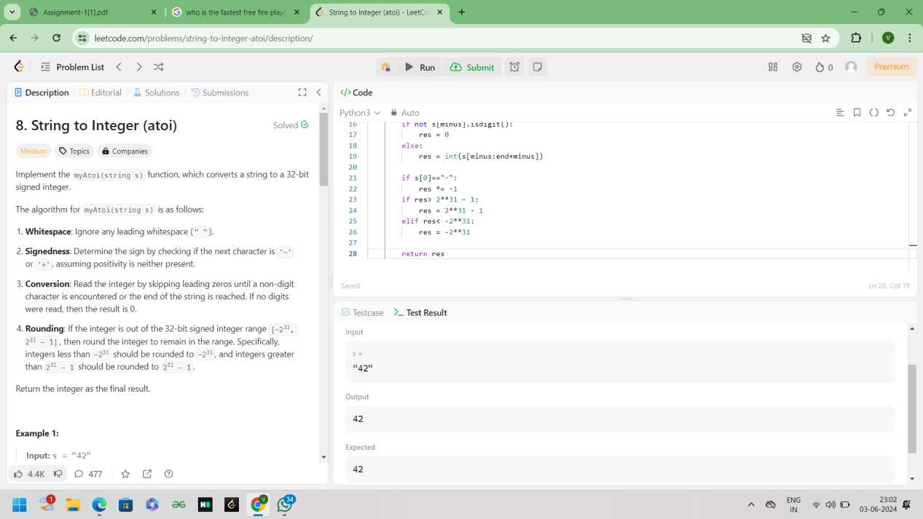

9. Palindrome Number Given an integer x, return true if x is a palindrome, and false other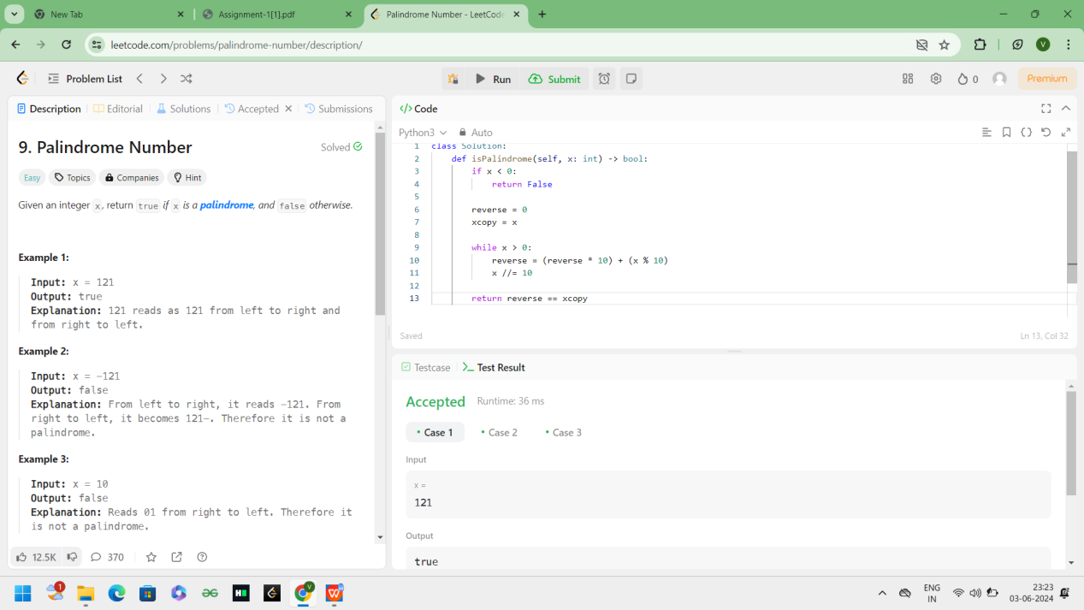wise.